How-to Password Protected a Word Document (Please use OT847 for password)
- Click on File, in top right hand corner of word document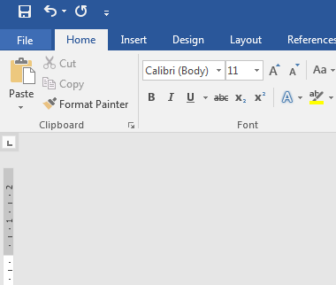

- Click on Protect Document and then choose Encrypt with Password 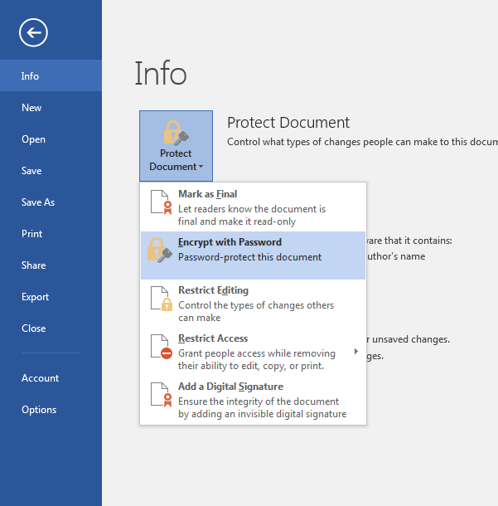

- Type Password (OT847) then click OK 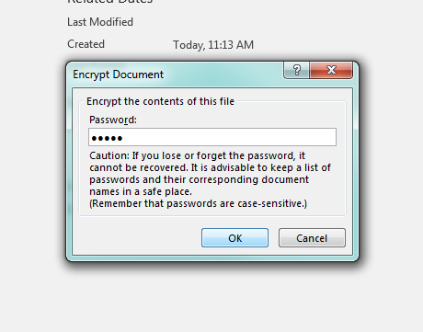

- Re-type Password (OT847) then click OK 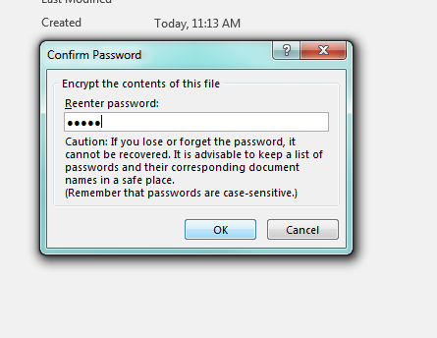

Your document is now password protected!!

